North Herts Road Runners

Potential new member details form

Please complete and email the form to Karen Dodsworth, Lead Coach, on coachesnhrr@gmail.com and our Membership Secretary Georgia Barker membershipnhrr@gmail.com. This information will be used to give you a trial period of 1 month on the app we use to book our training sessions, My Running Club. You are welcome to attend 2 sessions before deciding whether you wish to join. By returning this form you are consenting to NHRR adding your personal details into the club database on Connect My Club.
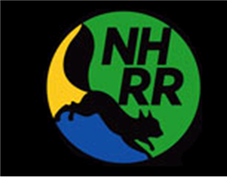
Name: |  |  | Title:
Telephone:
(including STD code)
Email
UK County of Birth:  (leave blank if not UK) |  | Date of Birth | Male:
 |  |  | Female:
Address: | Postcode:
Emergency Contact Name:
Emergency Contact Telephone:
(including STD code)
Medical information  Do you use an inhaler?  Do you have any allergies?  Please give details if yes.  Is there any medical information that we should be aware of? We would pass this on to medical personnel in case of an emergency. |  |  |  | Y / N  Y / N
Please provide some information about your current running ability including the time that you can run 5km. This will help us suggest the most appropriate training group for you

